BERDO Analysis Report
Identifying Reporting Gaps, Energy Performance Risks, and Emissions Reduction Opportunities in Boston Buildings
2025 Reported Energy and Water Metrics
Dataset: 5,580 Buildings | 54 Variables | Python & pandas Analysis

Prepared by Ryan Kelly
Data Analytics Student, Northeastern University

1. Executive Summary
This report analyzes Boston's 2025 BERDO building dataset to identify where compliance challenges and energy reduction opportunities are most concentrated. BERDO compliance is shaped by two distinct challenges: reporting failure and operational performance.

The strongest finding is that missing property type data is not randomly distributed. Buildings with missing classification are heavily concentrated in noncompliant reporting categories, indicating that missing data functions as a structural signal of compliance risk rather than a simple data quality issue.

High Site Energy Use Intensity (EUI) is concentrated in buildings with greater operational complexity, including manufacturing, laboratory, and other specialized uses. These buildings may be in compliance administratively while still facing significant long-term retrofit difficulty.

These findings suggest that BERDO implementation should not rely on a single intervention strategy. Buildings with missing reporting data require outreach, technical assistance, and ownership coordination support, while high-EUI buildings require deeper retrofit planning, financing pathways, and engineering support.

5,580  Total Buildings  in 2025 BERDO dataset | 64%  In Compliance  3,569 buildings | 28.3%  Not Submitted  1,579 buildings | 34.1%  Reporting Support Needed  missing EUI or property type

Tools & Methods
- Python (pandas, matplotlib, numpy)
- Microsoft Excel for initial data exploration
- 2025 BERDO Reported Energy and Water Metrics dataset (5,580 rows, 54 columns)

2. Key Findings

2.1. Missing Data as a Compliance Signal
1,579 buildings across the full dataset fall into the not submitted category. Buildings with missing property type are overwhelmingly concentrated within this group — 1,579 of 1,653 buildings (95.5%) missing a property type are also not submitted, suggesting these two data gaps occur together rather than independently.

Key Observation: Missing property type is not random noise — it is a measurable signal of buildings at highest risk of noncompliance.

2.2. Two Distinct Intervention Groups
BERDO compliance challenges fall into two categories requiring fundamentally different responses:

Group 1: Reporting Support | Group 2: Retrofit Planning
Buildings with missing or incomplete reporting data need:  - Outreach and contact identification  - Simplified reporting pathways  - Owner coordination support  - Technical reporting assistance | Buildings with high Site EUI need:  - Energy audit and retrofit planning  - Financing pathway access  - Engineering and decarbonization support  - Long-term capital planning assistance

2.3. Multifamily is Largest Category but Not the Biggest Gap
Multifamily Housing has more than 2,000 buildings, making it the largest category in the dataset. However, the biggest reporting gap is concentrated in the No Property Type group, not multifamily. Multifamily has a 2.5% missing Site EUI rate, while the No Property Type group is at 99.9%.

2.4. Ownership Complexity Drives Reporting Gaps
Buildings missing property type are spread across LLCs, public sector entities, condominiums, individuals, trusts, and corporate owners. This suggests that reporting gaps are tied to administrative complexity, fragmented ownership, or limited reporting capacity — not simple oversight.

2.5. Energy Intensity Varies by Function, Not Size
Correlation between gross floor area and Site EUI is approximately 0.099 — meaning larger buildings are not automatically more energy intensive per square foot. Building function is the dominant driver of energy intensity.

2.6. Specialized Buildings Show Highest Site EUI
Restaurants, fast food restaurants, healthcare facilities, laboratories, supermarkets, data centers, and industrial uses show some of the highest average Site EUI values. These buildings likely need tailored energy strategies because their energy use is tied to specialized operations, not simply building size.

3. Data Quality and Preparation

3.1. Dataset Overview
The analysis uses the 2025 BERDO-reported Energy and Water Metrics dataset for Boston buildings. After initial loading, the dataset contained 5,580 rows and 54 columns. Missing values were present across multiple fields.

Data was cleaned using Python and pandas with the following preprocessing steps:
- Standardizing column names for easier querying and analysis
- Renaming major variables (property type, Site EUI, emissions, compliance status) for clarity
- Removing records with missing Site EUI when energy performance comparisons required valid observations
- Preserving the full dataset separately for reporting gap and missing data analysis

3.2 Data Quality Summary
Data Quality Metric | Result
Initial Records | 5,580
Records with Valid Site EUI | 3,678
Records Removed (Missing EUI) | 1,902
Percent Removed | 34.1%

Removing records with missing Site EUI improves the reliability of energy performance comparisons. Preserving the full dataset separately ensures that compliance failures are not hidden during cleaning, this distinction separates operational performance analysis from reporting completeness analysis.

4. Compliance Distribution

4.1 Overall Distribution
The dataset is heavily concentrated in the in compliance category, with 3,569 buildings (64.0%) meeting BERDO reporting requirements. A significant group of 1,579 buildings falls into the not submitted category, representing a major portion of Boston's building stock.

Compliance Status | Building Count | % of Buildings
In Compliance | 3,569 | 64.0%
Not Submitted | 1,579 | 28.3%
Pending Revisions | 223 | 4.0%
State | 116 | 2.1%
Unknown/Missing | 93 | 1.7%

Key Observation: 1,579 buildings (28.3%) have not submitted compliance data — representing the highest-priority intervention group for outreach and reporting support.

Rather than representing isolated exceptions, noncompliant buildings may represent the highest-impact intervention group because they combine both reporting failure and likely future retrofit difficulty. This supports the need for targeted outreach and proactive compliance support rather than reactive enforcement.

5. Missing Property Type and Compliance Risk

5.1 Property Types with Highest Missing Site EUI Rates
Buildings with missing property type are highly concentrated in records with missing energy performance data. The No Property Type category contains 1,653 total buildings, with 1,652 missing Site EUI — a 99.9% missing rate. By comparison, Multifamily Housing, the largest building category with 2,104 buildings, has only 52 records missing Site EUI (2.5%).

Property Type | Total Buildings | Missing Site EUI | % Missing EUI
No Property Type | 1,653 | 1,652 | 99.9%
Multifamily Housing | 2,104 | 52 | 2.5%
Office | 455 | 30 | 6.6%
College/University | 310 | 65 | 21.0%
K-12 School | 167 | 4 | 2.4%
Self-Storage Facility | 38 | 13 | 34.2%
Worship Facility | 40 | 3 | 7.5%
Hotel | 66 | 0 | 0.0%
Laboratory | 50 | 2 | 4.0%

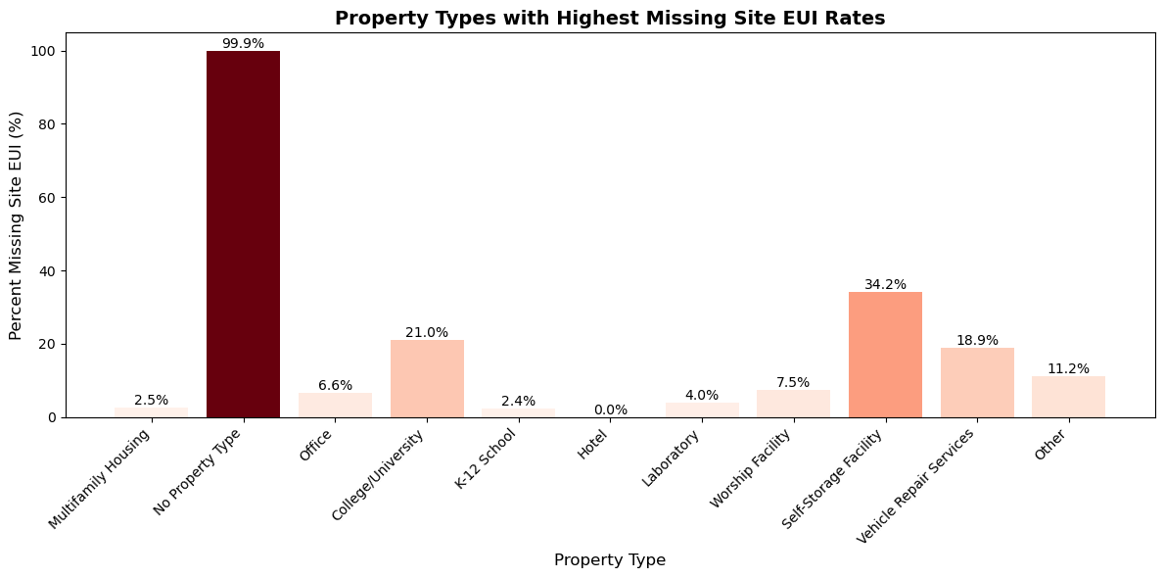
When property type is present, only 6.4% of buildings are missing Site EUI. When property type is missing, 99.9% are also missing Site EUI. This co-occurrence is not coincidental; it reflects the same underlying failure to engage with the BERDO reporting system.

5.2. Compliance Status of Buildings Missing Property Type
None of the buildings with missing property type are classified as In Compliance. The majority fall under Not Submitted, with a smaller portion in the State pathway.

Compliance Status | Count | Percent (%)
Not Submitted | 1,579 | 95.99%
State | 65 | 3.95%
Pending Revisions | 1 | 0.06%

Key Observation: Zero buildings with missing property type are classified as In Compliance — confirming that missing data is a structural indicator of noncompliance risk, not a data entry error.

6. Ownership Structure and Compliance Barriers

6.1. Ownership Type Distribution
Missing property type information is concentrated among LLC-owned (20.21%), public sector (18.51%), and condominium (17.73%) buildings, which together account for approximately 56% of cases. These ownership structures often involve shared governance, institutional management, or fragmented legal entities.

Ownership Type | Count | Percent (%)
LLC | 334 | 20.21%
Public Sector | 306 | 18.51%
Condominium | 293 | 17.73%
Individual | 178 | 10.77%
Trust | 118 | 7.14%
Corporate | 115 | 6.96%
Nonprofit | 83 | 5.02%
Other | 63 | 3.81%
Partnership | 50 | 3.02%
Education | 27 | 1.63%

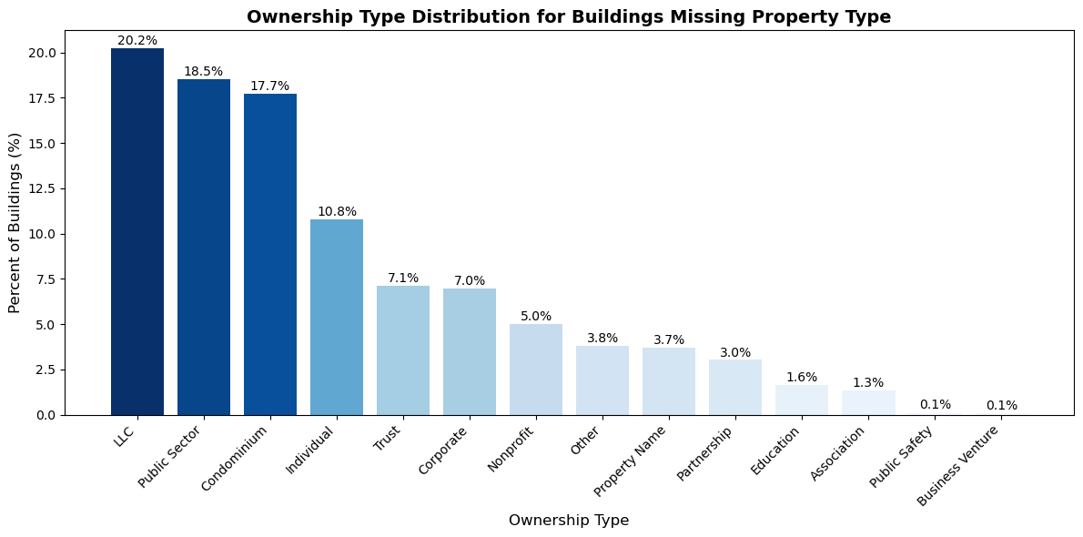
Common barriers identified through both quantitative analysis and stakeholder interviews include:
- Difficulty identifying responsible building owners
- Limited technical capacity among smaller and fragmented ownership groups
- Complex and time-intensive reporting processes
- Limited access to engineering expertise and retrofit planning support
- Absence of dedicated facilities staff or long-term capital planning systems

These factors help explain why some buildings submit incomplete data or fail to report entirely. Compliance is not only a technical challenge, but also an organizational and administrative one.

7. Energy Performance Analysis

7.1. Average Site EUI by Compliance Status
Buildings in the State compliance pathway show a higher average Site EUI than buildings marked In Compliance. This suggests that some compliance pathways include more energy-intensive buildings that face greater long-term retrofit difficulty.

Compliance Status | Average Site EUI (kBtu/ft²)
State | 92.03
In Compliance | 76.41
Pending Revisions | 73.99

7.2. Average Site EUI by Property Type
Energy use intensity varies significantly across property types. Building function — not building size — is the primary driver of energy intensity. The correlation between gross floor area and Site EUI is approximately 0.099, indicating virtually no relationship between building size and energy intensity per square foot.

Property Type | Average Site EUI (kBtu/ft²)
Restaurant | 336.85
Fast Food Restaurant | 333.50
Zoo | 271.90
Urgent Care/Clinic/Other Outpatient | 253.67
Hospital (General Medical & Surgical) | 236.18
Laboratory | 233.25
Supermarket/Grocery Store | 226.98
Ambulatory Surgical Center | 208.35
Other - Technology/Science | 196.59
Data Center | 144.05
Manufacturing/Industrial Plant | 142.50
Office | 60.99
Multifamily Housing | 67.79
K-12 School | 64.00

Key Observation: Restaurants, healthcare facilities, laboratories, and supermarkets show Site EUI values 3-5x higher than office or multifamily buildings — requiring specialized, function-specific energy strategies.

7.3. High-EUI Outlier Buildings
Most of the highest-EUI buildings (Site EUI > 200) are still classified as In Compliance, indicating that compliance status is not determined solely by energy intensity. Notable high-EUI buildings include:
- 20 Gillette Park (Manufacturing, Site EUI: 667.70) — In Compliance
- 1 Jimmy Fund Way (Laboratory, Site EUI: 467.90) — In Compliance
- 450-458 Brookline Ave (Urgent Care, Site EUI: 419.30) — In Compliance
- 500 Soldiers Field Rd (Manufacturing, Site EUI: 408.40) — In Compliance

These buildings present long-term retrofit challenges regardless of current compliance status and should be priority candidates for deeper energy reduction planning.

7.4 Estimated GHG Emissions Intensity and BERDO Standards Context

Because BERDO emissions performance is measured in kg CO₂e per square foot per year, the analysis also calculated estimated GHG emissions intensity by dividing reported GHG emissions by reported gross floor area. This provides a closer connection to BERDO’s official emissions-performance framework than Site EUI alone.

The estimated GHG intensity comparison should be interpreted as exploratory rather than as a final compliance determination. A complete BERDO compliance assessment would require official building-use classification, blended standards for mixed-use buildings, verified emissions calculations, compliance-year rules, and any approved flexibility measures.

This additional comparison strengthens the screening framework by distinguishing between energy-use intensity and emissions-performance context.

8. Building Prioritization Framework
8.1. Complexity Classification
Buildings were classified into three complexity tiers based on likely retrofit and ownership challenges. These are analytical groupings, not official BERDO classifications, intended to identify where additional outreach, technical assistance, or retrofit planning may be needed.

Complexity Tier | Included Property Types | Rationale
High Complexity | Multifamily, Residential, Mixed-Use | Split ownership, limited capital planning, retrofit coordination difficulty
Moderate Complexity | Office, Retail, Hotel | Clearer ownership structure, meaningful compliance and retrofit challenges
Low Complexity | University, Hospital, Laboratory | Stronger capital access, dedicated facilities teams, structured energy management

8.2. Priority Matrix Results
Buildings were segmented by combining their Site EUI classification (above or below median) with their complexity tier. The median Site EUI threshold used for classification was 63.30 kBtu/ft².

Building Segment | Count | Priority | % of Dataset
High EUI + High Complexity | 1,003 | HIGH | 27.3%
High EUI + Moderate Complexity | 630 | MEDIUM | 17.1%
Low EUI + High Complexity | 1,064 | MEDIUM | 28.9%
High EUI + Low Complexity | 201 | MEDIUM | 5.5%
Low EUI + Moderate Complexity | 663 | LOW | 18.0%
Low EUI + Low Complexity | 116 | LOW | 3.2%

1,003 buildings (27.3% of analyzed buildings) fall into the High Priority category — combining above-median Site EUI with high ownership/retrofit complexity. Of these, 97.78% are currently In Compliance, meaning they face long-term retrofit challenges even while meeting current administrative requirements.

9. BERDO Intervention Type Summary

Buildings were classified into three intervention groups based on data completeness and energy performance. This framework translates analytical findings into actionable policy categories.

Intervention Type | Buildings | % of Total | Recommended Action
Reporting Support | 1,903 | 34.1% | Outreach, reporting assistance, ownership coordination
Retrofit Planning | 1,840 | 33.0% | Long-term energy reduction, financing, technical assistance
Monitor | 1,837 | 32.9% | Continue compliance, periodic review

Key Observation: Approximately one-third of all Boston BERDO buildings fall into each intervention category — requiring sustained, parallel efforts across all three tracks rather than a sequential approach.

10. Conclusion
This analysis reveals that BERDO compliance is shaped by two distinct but connected challenges: data completeness and building performance.

The first challenge is data completeness. A significant portion of buildings have not submitted the required information entirely, and this is strongly associated with missing property classification. Buildings without an assigned property type are overwhelmingly concentrated in noncompliant reporting categories, demonstrating that missing data is a structural indicator of compliance risk, not a technical data quality problem.

The second challenge is operational performance. Among buildings that do report, Site Energy Use Intensity varies significantly across property types. Restaurants, healthcare facilities, laboratories, supermarkets, industrial buildings, and other specialized uses show the highest average Site EUI values. These buildings face a different type of compliance pressure: not necessarily reporting failure, but deeper operational and retrofit complexity.

Achieving meaningful emissions reductions under BERDO will require more than targeting high-energy buildings alone. It will require improving data completeness, reducing reporting friction, and supporting under-resourced ownership groups that struggle to engage with compliance systems. The primary barrier to effective climate policy implementation in this context is not only energy performance, but also data visibility and ownership structure, which shape how buildings engage with and comply with BERDO requirements.

By adding estimated GHG emissions intensity alongside Site EUI, the analysis distinguishes between energy-use screening and emissions-performance context while avoiding a final compliance determination without official BERDO building-use mapping and blended-standard calculations.

Final Takeaway
BERDO compliance is not only an energy performance challenge. It is also a data visibility, reporting capacity, and ownership coordination issue. The buildings most in need of support are not limited to those with high Site EUI; they also include buildings missing basic reporting information, especially property type and energy use data. Considering missing data as an early warning signal can help identify where outreach, technical assistance, and retrofit planning should be prioritized.

11. Methodology

11.1. Data Sources and Preparation
The analysis uses the 2025 BERDO-reported Energy and Water Metrics dataset for Boston buildings. Core variables used in the analysis included: property type, Site Energy Use Intensity (Site EUI), total site energy usage, greenhouse gas emissions, compliance status, building size (gross floor area), and ownership patterns inferred from owner name classification.

11.2. Analytical Framework
The project combines descriptive analysis, comparative metrics, and rule-based prioritization to identify high-impact intervention groups. Key methods included:
- Compliance distribution analysis across the full dataset
- Property type and ownership gap analysis for missing records
- Grouped comparison of average Site EUI across compliance categories
- Correlation analysis between building size and energy intensity
- Complexity classification based on likely retrofit and ownership challenges
- Priority segmentation using both energy intensity and implementation complexity

